Pictures with Santa Fundraiser
Sunday, November 17th, 1pm-3pm
at Terra Cotta Country Store
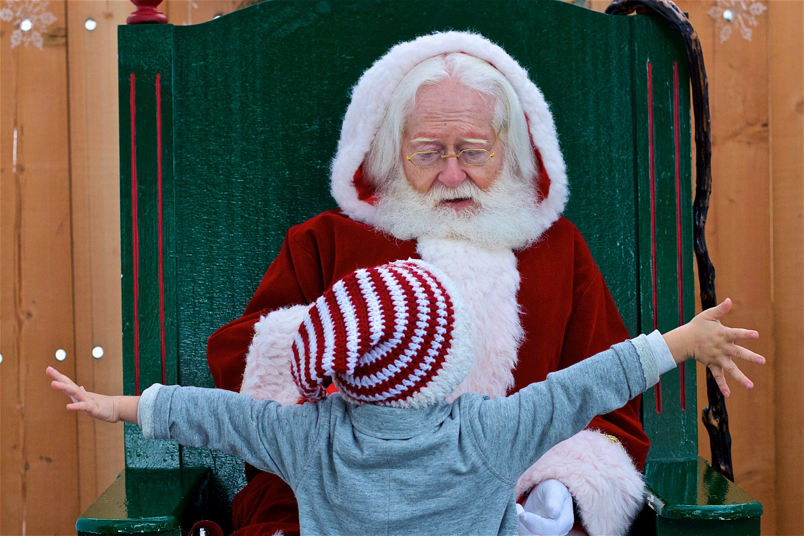
Donations to:

The Zach Sutherland & Kaya Firth Resiliency Foundation
People and pets welcome!

For more details visit:
www.terracottacountrystore.ca
www.choose2beresilient.com

